Class Discussion
November 18, 2008
Upper Six

Discussion on the HW.

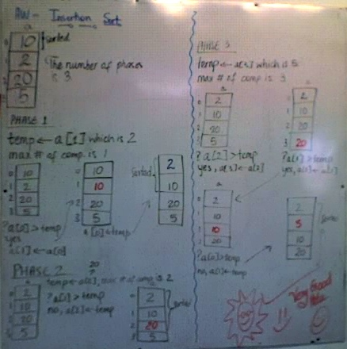

A test was given afterwards.

